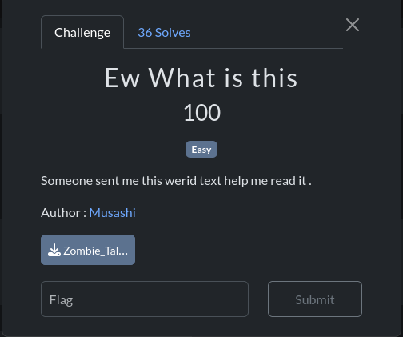**Challenge Name: Ew What is this**

We download the ‘txt’ file and then and display content with cat:

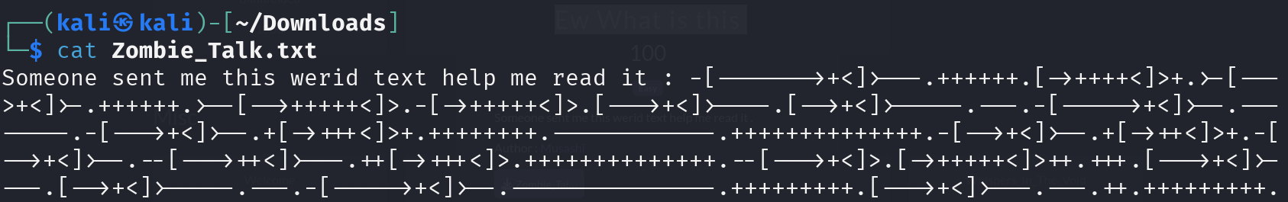

The text provided appears to be **Brainfuck** code, a minimalist esoteric programming language that operates on a memory tape. We can decode it using this website [**https://www.dcode.fr/brainfuck-language**](https://www.dcode.fr/brainfuck-language)**.**

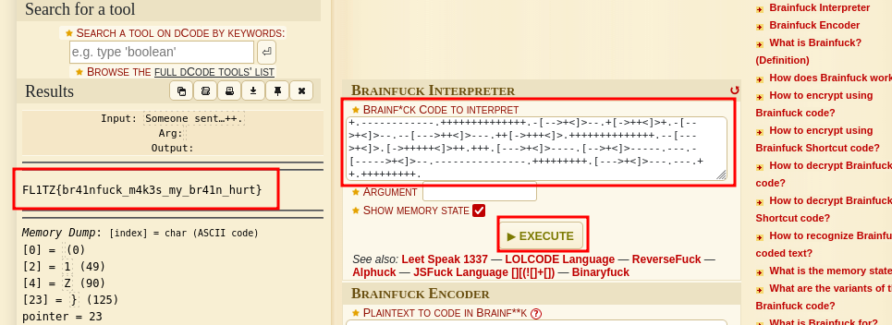

We Found our flag ‘FL1TZ{br41nfuck_m4k3s_my_br41n_hurt}’ and then hit submit.